1 Description: 3
2 Protocol between SCCOP_ADAPTER and Dot matrix device 3
2.1 The protocol’s scenarios 3
2.2 Serial Bus Interfaces for Dot matrix device 3
2.2.1 Message Framing 3
2.3 Dot matrix device Interface Messages Interaction 4
2.3.1 Handshake (Poll) 4
2.3.1.1 Function Code 08 - Diagnostics 4
2.3.1.2 e-inspection mode 5
2.3.2 Updates Dot matrix device 6
2.3.2.1 Function Code 16 (10 hex) – update Dot matrix device data 8
2.4 Basic outlook as follow 9
2.5 Appendix: CRC Generation 9
3 Risk to be checked 11
4 Reliablity 11
4.1 EMC Test 11
4.2 Climatic Test 11

CHANGE HISTORY

All changes are marked on the left border with |

Date | Version | Status / Description of changes | Resp.
19.08.20 | 0.0 | Initial Version

REFERENCES

# | Titel | Document | Ae | Date
1 | CMG –  Specification Amendment Proposal  - Not signed at the moment | F 45310218 | 00 | 2011-10-04
2 | TICO FI GS 100/300  Overview about all variants with ID numbers | EJ 41320445 | 06 | 2012-05-01
3 | FI GS Product Structures | J 41323000 | 06 | 2012-05-01
4 | Global Fixtures for CMG | EQ 41320405 | 08 | 2009-12-16
5 | TFT Configuration File | EJ 45331000 | 00 | 2008-03-17
6 | COP GS 300 FL - AUS | Q 41320720 | 00 | 2012-05-08
7 | SCCOP_ADAPTER Reqiurement and Concept | EQ 45331191 | 1.0 | 2016-11-16
8 | Quality Requirements for Glasses COP,LOP and LIP | J 41323005 | 01 | 2010-01-29
9 | Component Specs FI GS 100 / FI GS 300 | EQ 41320405 | 06 | 2009-12-16

Description:
The 3rd party display device is dot matrix device and TFT device.
TFT device protocol refer to “EQ_45620145_00_3rd party TFT protocol Spec.doc”
Dot matrix device protocol is described in this file

Protocol between SCCOP_ADAPTER and Dot matrix device
The protocol is used to updates 3rd party Dot matrix device by SCCOP_ADAPTER via RS485.

The protocol’s scenarios
The protocol scenarios are listed as bellows:
- Handshake at start up and get acknowledge from DOT MATRIX DEVICE.
The dialog between SCCOP_ADAPTER and Dot matrix device shall be initialized (handshake or poll) before executing any actions
- Update data on Dot matrix device.
SCCOP_ADAPTER sends display data to Dot matrix device for refresh. The display data includes arrows, position indications, date, time, and elevator status.
- Dot matrix device updates acknowledge
Dot matrix device will acknowledge SCCOP_ADAPTER to confirm that it receives the display data from SCCOP_ADAPTER

Serial Bus Interfaces for Dot matrix device
UART will be used as data driver. The UART is configured as:
- 19200 bps,
- 8 data bits,
- Odd parity,
- 1 stop bit,
- no HW/SW flow control.
This protocol defined as following is used for the data link layer and application layer.
In this protocol, SCCOP_ADAPTER will also act as master, while Dot matrix device act as slave node.
In SCCOP_ADAPTER system, only unicast mode is used while broadcast is not used. In unicast mode, the master addresses an individual slave. After receiving and processing the request, the slave returns a message ('reply') to the master. Each slave must have a unique address (1 to 247).

Message Framing
RTU mode is used for message transmission.
The format for each byte (11 bits) in RTU mode is:
Bits per Byte: 1 start bit
8 data bits, least significant bit sent first
1 bit for parity checking (odd parity)
1 stop bit
Odd Parity checking will be applied.
Each character or byte is sent in this order (left to right): Least Significant Bit (LSB) ... Most Significant Bit (MSB)
With Parity Checking
Start | 1 | 2 | 3 | 4 | 5 | 6 | 7 | 8 | Parity | Stop
Bit Sequence in RTU Mode

The data Frame is composed as following
Address | Function | Data | CRC
1 byte | 1 byte | N bytes | CRC_L (1 byte) | CRC_H (1 byte)

The entire message frame must be transmitted as a continuous stream of characters. The message frames are separated by a silent interval of at least 3.5 character times, that means the interval between 2 frames shall be more than 1.75ms

The slave address for the Position indicator is defined as “0x01”;
The function code indicates to the slave what kind of action to perform.
Data field that contains request and response parameters follows the function code.
The CRC field contains a 16 bits’ value implemented as two 8-bit bytes. Modbus CRC16 is used in this specification. (“sscom”(a Serial port tool) is used for testing (ModbusCRC16 creation and data translation). )

Dot matrix device Interface Messages Interaction
The SCCOP_ADAPTER will communicate with Dot matrix device with Function code 08 (Diagnostic), Function Code 16 (10Hex, Write Multiple Registers).
When SCCOP_ADAPTER sends out function code request to Dot matrix device, it will wait for the response from Dot matrix device, the maximum timeout is 150 ms for each response waiting.

Handshake (Poll)
The handshake (poll) shall be executed to establish a dialog between SCCOP_ADAPTER and display device
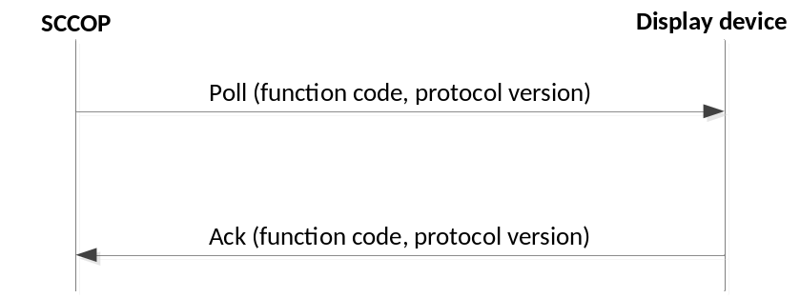
After SCCOP_ADAPTER send polling request to Dot matrix device, it shall send response/acknowledge to SCCOP_ADAPTER to handshake between them.
Parameter name | Parameter Type | Parameter Description
Handshake (poll)
Establish a dialog between SCCOP_ADAPTER and DOT MATRIX DEVICE
Function code | 1 byte | Function code 08
Data length | 2 bytes | The size of the data in byte (including Protocol version, excluding CRC data)
Protocol version | Number (>0), 2 byte | The protocol version: 0001

Function Code 08 - Diagnostics
Code | Name | Description
08 | Diagnostics | Provides a handshake for checking the communication system between the master and slave.

Query  Here is an example of a request to Dot matrix device 01 to Return Query Data. The data to be returned is sent in the two–byte data field (00 01 hex). | Response  The normal response to the Return Query Data request is to loopback the same data. The function code is also echoed.
  Field Name (Hex) | Example  (Hex)
  Slave Address | 01
  Function Code | 08
  Data Length Hi | 00
  Data Length Lo | 02
  Data Hi | 00
  Data Lo | 01
  Error Check (LRC or CRC) | ––
  Field Name (Hex) | Example  (Hex)
  Slave Address | 01
  Function Code | 08
  Data Length Hi | 00
  Data Length Lo | 02
  Data Hi | 00
  Data Lo | 01
  Error Check (CRC) | ––

e-inspection mode
Every dot should be tested in e-inspection mode by the dot matrix device
The testing process: every dot should be turned on and turn off. Then the respective current will be recorded. this dot testing is passed if the difference between these two current is reasonable.
There are two area on dot matrix device: floor name area and arrow area.
- E-inspection floor name area result is passed if all dot testing are passed in this area.
- E-inspection arrow area result is passed if all dot testing are passed in this area.
The function code 0x08 and sub-function code 0x05 are used in this mode

Diagnostic request SCCOP_ADAPTER→3rd party Car call button device
Establish a dialog between SCCOP_ADAPTER and 3rd party Car call button device
Parameter name | Parameter Type | Parameter Description
Address | 1 byte | 0x01: slave address
Function code | 1 byte | 0x08: Function code 08
Sub function code | 2 bytes | 0x0005  (return e-inspection result)
Data | 2 bytes | 0x0000  e-inspection result register address
Diagnostic respond SCCOP_ADAPTER←3rd party Car call button device
Establish a dialog between SCCOP_ADAPTER and 3rd party Car call button device
Parameter name | Parameter Type | Parameter Description
Address | 1byte | 0x01: slave address
Function code | 1 byte | 0x08: Function code 01
Sub function code | 2 bytes | 0x0005
Data | 2 bytes | Data value (Reg address:0x0000)  Reference as follow

e-inspection result register 0x0000 description as follow:
Reg Addr for  Restriction | bit15 | bit14 | bit13 | bit12 | bit11 | bit10 | bit9 | bit8 | bit7 | bit6 | bit5 | bit4 | bit3 | bit2 | bit1 | bit0
0x0000 | e-inspection item |  |  |  |  |  |  |  | e-inspection result

The meaning (e-inspection item) as follow:
bit 8:15 | e-inspection item meaning
0x01 | e-inspection result was done in Floor name display area
0x02 | e-inspection result was done in arrow display area
0x00 | e-inspection is ongoing, so e-inspection result will be ignored by SCCOP_ADAPTER
0xff | all e-inspection results (both Floor name display area and arrow display area) were already replied

The meaning (e-inspection result for arrow) as follow:
Bit 0:7 | meaning
Bit 0 | 1: corresponding button e-inspection result is passed  0: corresponding button e-inspection result is failed
Bit 1 | 1: any one of buttons was pressed  0: any one of buttons was not pressed
Bit 2:7 | These 6 bits are ignored (the value is 111111)

The table for e-inspection item and e-inspection result as follow:
e-inspection item | e-inspection result
0x00  (e-inspection is ongoing) | e-inspection result is ignored by SCCOP_ADAPTER  so bit0:7 value is default value(0xff)
0x01  (e-inspection result was done in Floor name display area) | Bit0: 1/0  Bit1: 0  Bit2:7 111111
0x02  (e-inspection result was done in arrow display area) | Bit0: 1/0  Bit1: 0  Bit2:7 111111
0xff  (all e-inspection results (both Floor name display area and arrow display area) were already replied) | 0xff

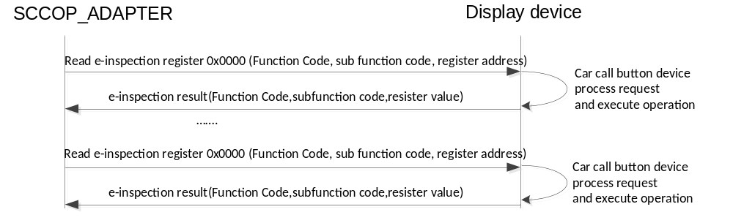

Updates Dot matrix device
SCCOP_ADAPTER will update Dot matrix device data as following:
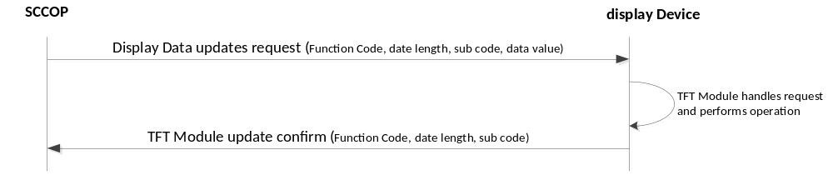

The SCCOP_ADAPTER send Dot matrix device data updates request with the updated data to DOT MATRIX DEVICE. DOT MATRIX DEVICE will respond to SCCOP_ADAPTER to confirm display data have been updated within specified timeout.
The expected maximum timeout between request and response Messages is specified in this protocol
 | Parameter name | Parameter Type | Parameter Description
Display data updates request
Display data updates request to Dot matrix device
Function code |  | 1 byte | Function code 0x10
Data length |  | Hex, 2 bytes | The size of the data in byte (including sub code and data, excluding CRC data)
Sub Code |  | Number (>0), 1 bytes | Specify which data to be updated (e.g. 0x01: Update Arrows)
Data value |  | Hex, N bytes | The data to be updated.
Display data updates request response
DOT MATRIX DEVICE gives response to SCCOP_ADAPTER to confirm the display data has been updated.
 | Function code | 1 byte | Function code 0x10
 | Date length | Hex, 2 bytes | The size of the data in byte(including sub code)
 | Sub code | Number (>0), 1 bytes | Same as the request received from SCCOP_ADAPTER.

Item | Data length | Sub code | Data description
Arrow | 3 | 0x01 | Hi byte = State of arrow up  Lo byte = state of arrow down.  States can be 1 = light on or 0 = light off.  0x0000 = switch off both arrow up and arrow down  0x0001 = switch off arrow up, switch on arrow down  0x0100 = switch on arrow up, switch off arrow down  0x0101 = shows both arrow up & down  switch off both arrow up and arrow down if cannot be displayed on TFT
Position Indications | 6 | 0x02 | ASCII representation of position indication on Dot matrix device.  B4 B3 B2 B1 B0  B4:  0x01 = The position indication data will be refreshed on dot matrix with “B3 B2 B1 B0”  0x00 = The position data will be added on the left of current displayed data on LCD.  B3: The 4th display data (from right to left)  B2: The 3rd display data (from right to left)  B1: The 2nd display data (from right to left)  B0: The 1st display data (from right to left)  The character to be displayed refers to the standard ASCII character set.  From left to right, no matter B4 is 0x00 or 0x01, only display B3 to B0 from the first data not “20” (blank) to the last one.  e.g.  01 20 31 32 41 → The position indication on LCD will be refreshed and “12A” will be displayed.  01 20 31 20 41 → The position indication on LCD will be refreshed and “1 A” will be displayed.  00 20 31 32 41 → “12A” will be displayed on the left of the current display data in LCD
Date | 5 | 0x03 | 1st byte: Hi byte of Year (2014 -> 0x07DE) → 0x07;  2nd byte: Lo byte of Year (2014 -> 0x07DE) → 0xDE;  3rd byte: Month; 0x01→Jan. … 0x0C→Dec.  4th byte: Day; 0x01→1. … 0x1E→30  e.g.: 07 DE 03 1B → 2014.03.27  note：Date can be updated as follow:  - Remote data frame from COP  - Locale date changed  So remote “Date” should be converted to locale date as remote “Date” was received. Then “Date” should be kept on updating by locale date
Time | 3 | 0x04 | Hi Byte: Hour, (24 Hours). 0x00→0: 0x17 → 23:  Lo Byte: Minute. 0x00→00, 0x3B→59  e.g. 11 21 → 17:33  note：Time can be updated as follow:  1.Remote data frame from COP  2.Locale Time changed  So remote “Time” should be converted to locale time as remote “Time” was received. Then “Time” should be kept on updating by locale time
Elevator Status | 3 | 0x05 | Hi Byte, = Symbol position;  Lo byte = State: 1 = light on; 0 = light off  e.g. 02 01 → No.2 symbol lit On
  meaning | Default symbol | note
  01 01 No.1 symbol lit on  01 00 No.1 symbol lit off | 
    Consigurable symbol
  02 01 No.2 symbol lit on  02 00 No.2 symbol lit off | 
    Consigurable symbol
  03 01 No.3 symbol lit on  03 00 No.3 symbol lit off | 
    Consigurable symbol
  05 01 No.4 symbol lit on  05 00 No.4 symbol lit off | 
    Consigurable symbol
Eco mode | 2 | 0x06 | Value:  0x01: Power saving Mode  0x00: Back to normal operation mode {jsy}
Floor range info | 8 | 0x07 | Value:  1st byte: total number of floors ;  2nd byte: lowest floor name Hundreds ASCII code;  3rd byte:. lowest floor name Tenths ASCII code  4th byte: lowest floor name Units ASCII code  5th byte: topmost floor name Hundreds ASCII code;  6th byte:. topmost floor name Tenths ASCII code  7th byte: topmost floor name Units ASCII code  e.g.: 15 20 2d 33 20 32 31 →  15: have total 21 floors  20 2d 33: “-3” the lowest floor range name  20 32 31: “21” the highest floor range name
Register floor | 0x1A | 0x08 | Value: 24 data bytes + 1 blinking byte  1st byte: Hundreds of 1st indication (ASCII code)  2nd byte: Tenths of 1st indication (ASCII code)  3rd byte:. Units of 1st indication (ASCII code)  4th byte: Hundreds of 1st indication (ASCII code)  5th byte: Tenths of 2nd indication (ASCII code)  6th byte: Units of 2nd indication (ASCII code)  7th byte: Hundreds of 3rd indication (ASCII code)  8th byte: Tenths of 3rd indication (ASCII code)  9th byte: Units of 3rd indication (ASCII code)  10th byte: …………..  …………..  …………..  22th byte: Hundreds of 8th indication (ASCII code)  23th byte: Tenths of 8th indication (ASCII code)  24th byte: Units of 8th indication (ASCII code)  25th byte: Blinking byte, If bit is set, it will blink the respective indication.  ---Bit7:blink the 8th indication  ---Bit6:blink the 7th indication  …………..  ---Bit0:blink the 1st indication  Note : the max register floor indication number is 8.
Inputs registering floor | 4 | 0x09 | Value:  1st byte: registering floor Hundreds ASCII code;  2nd byte: registering floor Tenths ASCII code;  3nd byte: registering floor Units ASCII code;  e.g.: 20 20 37 → “7”

Function Code 16 (10 hex) – update Dot matrix device data
Code | Name | Description
16  (10 hex) | update Dot matrix device data | Update Arrow, Position Indication, Date, Time and Elevator Status.

Query
The query message specifies the content to be show in Dot matrix device.
Here is an example of a request to show arrow down and up
Field Name (Hex) | Example  (Hex)
Slave Address | 01
Function Code | 10
Data length Hi | 00
Data length Lo | 03
Sub code | 01
Data first byte | 01
Data second byte | 01
Error Check (CRC) | ––

Response
The normal response returns the slave address, function code, data length, content code.
Here is an example of a response to the query shown above.
Field Name (Hex) | Example  (Hex)
Slave Address | 01
Function | 10
Data length Hi | 00
Data length Lo | 01
Sub code | 01
Error Check (CRC) | ––

Basic outlook as follow
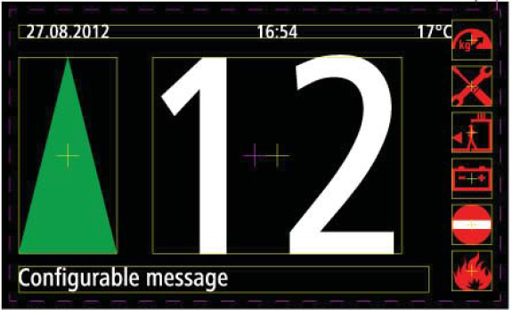

Appendix: CRC Generation
The Cyclical Redundancy Checking (CRC) field is two bytes, containing a 16–bit binary value. The CRC value is calculated by the transmitting device, which appends the CRC to the message. The device that receives recalculates a CRC during receipt of the message, and compares the calculated value to the actual value it received in the CRC field. If the two values are not equal, an error results.
The CRC is started by first preloading a 16–bit register to all 1’s. Then a process begins of applying successive 8–bit bytes of the message to the current contents of the register. Only the eight bits of data in each character are used for generating the CRC. Start and stop bits and the parity bit, do not apply to the CRC.
During generation of the CRC, each 8–bit character is exclusive ORed with the register contents. Then the result is shifted in the direction of the least significant bit (LSB), with a zero filled into the most significant bit (MSB) position. The LSB is extracted and examined. If the LSB was a 1, the register is then exclusive ORed with a preset, fixed value. If the LSB was a 0, no exclusive OR takes place.
This process is repeated until eight shifts have been performed. After the last (eighth) shift, the next 8–bit character is exclusive ORed with the register’s current value, and the process repeats for eight more shifts as described above. The final content of the register, after all the characters of the message have been applied, is the CRC value.
A procedure for generating a CRC is:
- Load a 16–bit register with FFFF hex (all 1’s). Call this the CRC register.
- Exclusive OR the first 8–bit byte of the message with the low–order byte of the 16–bit CRC register, putting the result in the CRC register.
- Shift the CRC register one bit to the right (toward the LSB), zero–filling the MSB. Extract and examine the LSB.
- (If the LSB was 0): Repeat Step 3 (another shift).
(If the LSB was 1): Exclusive OR the CRC register with the polynomial value 0xA001 (1010 0000 0000 0001).
- Repeat Steps 3 and 4 until 8 shifts have been performed. When this is done, a complete 8–bit byte will have been processed.
- Repeat Steps 2 through 5 for the next 8–bit byte of the message. Continue doing this until all bytes have been processed.
- The final content of the CRC register is the CRC value.
- When the CRC is placed into the message, its upper and lower bytes must be swapped as described below.

Risk to be checked
- If magnet for COP locking will be used, check the influence to the Dot matrix device and to the electronic parts.
- Check cable routing on (space behind electronic inside COP and the interface (entry/exit point) on the CAR
- Check space for the Dot matrix device in combination with all the cable
- Check opening and closing of COP, must be fault free and reliable even if some tolerances are not perfect managed.
- Check gluing area for glasses in combination with bigger cut out for display.

Reliablity

EMC Test
The COP with Display must comply with the requiremenst of EN 12015:2004 and EN12016:2004.
Tests are performed at system level.

Climatic Test
The Schindler standard climatic tests (transportation and operation),
according EQ 41009001 and EQ 41009902 have to be fulfilled.
For more detailed information, see also test requirements in basic specification of FI GS → reference #9

